

THE LONDON BOROUGH OF RICHMOND UPON THAMES (“RICHMOND COUNCIL”)

CONTRACT FOR

Ice Cream and Catering Vending Concessions

___________________
VOLUME TWO
SPECIFICATION
___________________

THE LONDON BOROUGH OF RICHMOND

  - The London Borough of Richmond upon Thames is a prosperous, safe and healthy borough. It covers an area of 5,095 hectares (14,591 acres) in southwest London. With a river frontage of 21.5 miles it is the only London borough spanning both sides of the Thames.

  - The main town centre is Richmond and there are four district centres at Twickenham, Teddington, East Sheen and Whitton. The borough is divided into 18 electoral wards, each ward is served by three Borough Councillors.

  - The total population of the borough is 189,000 and there are around 80,000 households of at least one usual resident.

  - Richmond is famous for its open spaces. In addition to the world-famous sites such as Richmond Park, Kew Gardens and Richmond riverside, there is also an extensive network of smaller open spaces and green routes in the borough which are well used and highly valued by residents and visitors. There are 21 parks and green spaces that hold the accolade of green flag status, achieving exceptional quality standards, including two of those available in this catering opportunity. Richmond’s outdoor spaces are regularly used for a wide range of activities.

BACKGROUND INFORMATION

  - The Council is seeking ice cream and catering suppliers (from here on known as the Contractor) to operate mobile ice cream concessions at designated sites within the borough.

  - Traditionally this contract has operated from four sites in close proximity to Richmond for a twelve-month season from 1st April to 31st March. Those sites are Ham Street Car Park, Richmond Riverside, Richmond Green and Buccleuch Gardens.
  - It is the aim of the Council to expand the services offered through this contract to benefit other areas within the borough.

  - The contract covers will not be split into lots.

SITES

  - Specific site location plans are detailed in Appendix A but consist of:

  - Lot 1:
- Richmond Riverside
- Richmond Green
- Ham Street Car Park
- Buccleuch Gardens

  - Lot 2:
- Richmond Riverside (Complementary Catering Offer)

Lot 1
Richmond Riverside

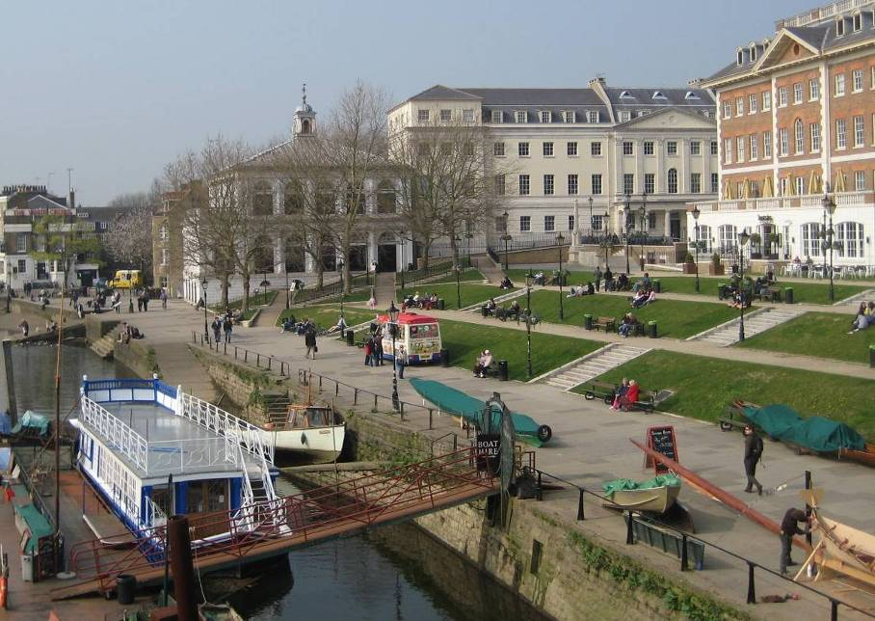

Map of Richmond Riverside

  - Famous for lazy summer evenings, this open space overlooks the River Thames in Richmond. Bustling bars and restaurants align the riverside, providing an ideal place for people to relax and unwind on the many seats and grassy lawns.

  - Richmond Riverside is a lively, busy location throughout the year and is popular with locals and visitors alike.

  - The pitch for the concession is located on the footpath between the two slipways in front of the lawns.

  - The successful supplier(s) will be required to enter into dialogue with the Council and local groups to mitigate any potential environment nuisances caused by the operation of any vehicle used for the concessions to other site users and businesses situated around the site.

  - An electricity point is present on site and the Contractor at this site will at all times be expected to use the electrical hardware provided by the Council, taking responsibility for the electricity cupboard and arranging for the meter to be in their name and meeting all meter payments.

Richmond Green

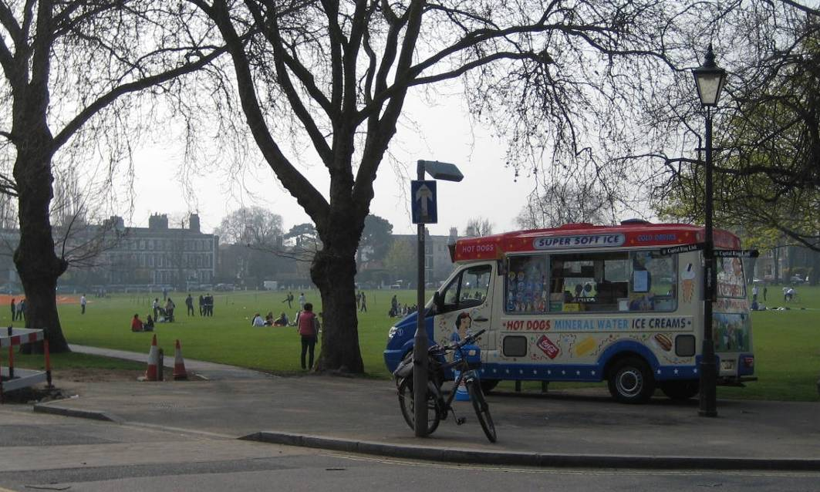

Map of Richmond Green

  - Richmond Green has been an important open space since the Middle Ages when it hosted jousting competitions. The green is surrounded by fine old houses and on the western edge the remnants of Richmond Palace can be seen. The central library and famous Richmond Theatre are located near the Green.

  - Visitors of all ages visit the green to relax with friends and family, particularly during the summertime on sunny days. There is also a cricket pitch on the green which hosts a number of local derbies during the cricket season.

  - The pitch for the concession is located on the eastern edge of the Green on the corner of Pembroke Villas and Portland Terrace.

  - There is an electricity point provided at this site. The Contractor at this site will at all times be expected to use the electrical hardware provided by the Council, taking responsibility for the electricity cupboard and arranging for the meter to be in their name and meeting all meter payments.

Ham Street Car Park

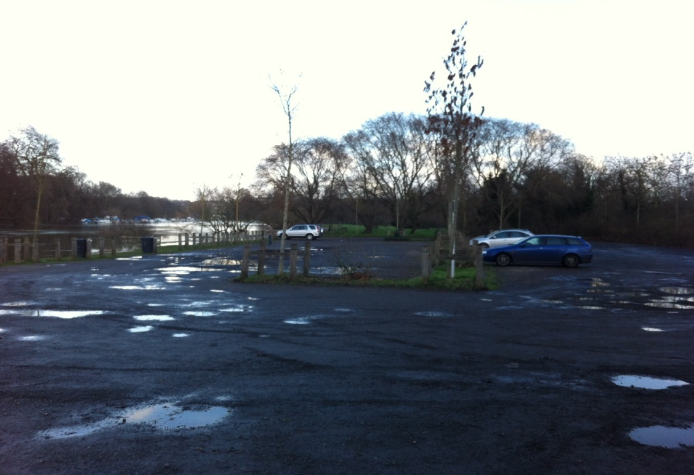

Map of Ham Street Car Park

  - Ham Street Car Park is located at the end of Ham Street on the edge of the River Thames. The car park is ideally situated for visitors to Ham House and Garden, a National Trust Visitor attraction and Ham Riverside Pitches, popular for football and other sports.

  - The pitch for the concession can be situated anywhere within the boundary of the car park.

  - There are no utilities provided at this site.

Buccleuch Gardens

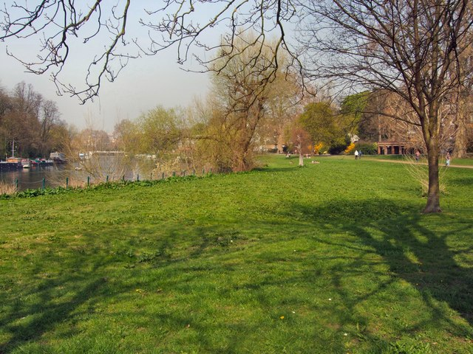

Map of Buccleuch Gardens

  - On the banks of the River Thames nestled between Richmond and Petersham is Buccleuch Gardens and neighboring Terrace Gardens. Both gardens are formally registered with English Heritage for their historical interest; the Gardens originate from the grounds of three private estates opened to the public as a park in 1887. A tunnel under Petersham Road links the two gardens. The gardens have recently undergone a major restoration program including hard surface repairs and new planting schemes.

  - Buccleuch Gardens is a large open green space with riverside views on the edge of the Thames path, with plenty of seating and toilet facilities.

  - The pitch for the concession is located 40m in from the Petersham Road entrance, on the grass by the pathside where it is not beneath the trees; this may be varied by agreement within limited parameters, but clear access shall be maintained for contractors and visitors at all times. Bollards may be erected to make this entrance secure in the near future.

  - There are no utilities provided at this site.

Lot 2

Richmond Riverside

Map of Richmond Riverside

  - Lot 2 is a separate Richmond Riverside trial concession, intended to provide a complementary catering offer rather than duplicate Lot 1. Tenderers must explain how their proposal adds variety, meets riverside demand and operates alongside existing traders without obstruction or displacement.

  - The concession will operate as a trial for the period stated in the contract documents. The Council will assess demand, site suitability, environmental impact, compatibility with Lot 1 and overall visitor benefit.

  - Before trading, the Contractor must agree mobilisation arrangements with the Council, including the start date, trading pattern, unit, offer, servicing, waste, power and access arrangements.

  - During the trial, the Council will monitor compliance, customer service, offer quality, affordability, waste, noise, emissions, pedestrian movement, complaints and relationships with nearby businesses and concessionaires.

  - The Council may require reasonable operational changes where needed for safety, access, environmental management or effective use of the riverside. Continuation beyond the trial is not guaranteed and will depend on satisfactory performance, approvals, licences and the Council’s assessment of suitability.

  - The pitch for the concession is located on the footpath between the slipways in front of the lawns and the bridge, across from the docked boats.

  - The successful supplier(s) will be required to enter into dialogue with the Council and local groups to mitigate any potential environment nuisances caused by the operation of any vehicle used for the concessions to other site users and businesses situated around the site.

  - An electricity point is present on site and the Contractor at this site will at all times be expected to use the electrical hardware provided by the Council, taking responsibility for the electricity cupboard and arranging for the meter to be in their name and meeting all meter payments.

LICENCES AT SITES

  - The sites at Richmond Riverside and Richmond Green require a licence. Richmond Green requires a licence because it is situated within 7 metres of the Green. Richmond Riverside requires a licence because it has been classified as a highway.

  - The annual licence fee per site is approximately £1,076 payable at the beginning of each financial year. The licence fee is subject to annual review and uplift at the discretion of the Council Licensing team.

  - The licence fee must be met by the successful Contractor for each applicable site each year and each Contractor is responsible for obtaining the licences by contacting the Licensing Department directly at:
Licensing
London Borough of Richmond upon Thames
2nd Floor
Civic Centre
44 York Street
Twickenham
Middlesex TW1 3BZ
Telephone: 020 8831 6455
Fax: 020 8891 7713
Email: licensing@richmond.gov.uk

A sample licence application form is provided in Appendix C.

  - Licences need to be in place before the successful supplier can operate on any of these sites. Please allow sufficient time to apply for the relevant licence.

  - Licences are subject to the Street Trading Standard Terms and Conditions detailed in Appendix B. All successful Contractors must abide by these Terms and Conditions.

CATERING REQUIREMENTS

  - It is the Councils’ ambition is to provide quality park environment catering services throughout the borough.

  - Those sites that require licences (Richmond Riverside and Richmond Green) are limited to selling ice-creams and cold refreshments only, however there is scope at all other sites to build upon this and provide a more varied offer of food and drink throughout the year

  - Lot 2 at Richmond Riverside will operate as a trial concession and may provide an alternative food and beverage offer, subject to the Council’s approval and any required street trading licence. This offer should complement, rather than duplicate, the Lot 1 concession and should add variety for visitors while remaining suitable for the riverside setting.

  - It is envisaged that the trading vans will offer a convenient quick snack service to visitors that offers high quality, great service and excellent value.

  - The food offer should have a seasonal flavour where possible and the use of fresh and ethically traded/sourced product is strongly encouraged. We do however understand that a balance is necessary between this type of item and other popular fare that one expects to find in a public park environment. Of utmost importance is a consistently high quality of food and service delivered throughout the year.

  - The sale of alcohol is not permitted at any of the sites.

MOBILE VEHICLES

  - It is the responsibility of the Contractor to provide vehicles from which the services will be operated.

  - The vehicles must mobile enough to be able to be removed from site every day. No vehicle can be left at any of the sites outside of the operating hours.

  - The contractor shall ensure that any vehicle used to perform the service complies with the latest European Emissions Standards and demonstrates the lowest CO² emissions levels and highest fuel economy with reference to the link below:

http://www.direct.gov.uk/en/Motoring/OwningAVehicle/HowToTaxYourVehicle/DG_10012524

  - The contractor shall ensure that any vehicle used to perform the service is regularly maintained to ensure optimum fuel efficiency and compliant with all current vehicle regulations.

  - All motor vehicles must be suitably insured and taxed to be driven on the highways.

  - The vehicle does not need to be a ‘traditional’ ice cream van; it may be that a bicycle is more suitable at some of the sites for example. The Council will accept proposals of alternative vehicles provided they meet the criteria detailed in this specification and are sympathetic to the park environment.

OPERATING HOURS

  - Trading hours are from 10:00am until sunset each day.

  - Trading outside of these hours is only permitted at any of the sites, with additional written approval by Council and relevant Street Trading Licences

  - Details of when the sun sets throughout the year can be found here.

OPERATIONAL CONSIDERATIONS

Health and Safety

  - The contractor shall at all times comply with all requirements of the Health and Safety at Work Act 1974 and associated regulations and guidelines.

  - The Contractor shall ensure that all persons employed in connection with the performance of the services shall at all times comply with the Food Safety and Hygiene (England) Regulations 2013, trading standards legislation and any other applicable legislation.

Indemnity and Insurance

  - The minimum insurance requirements for this contract are:

Policy Type | Minimum Requirement
Public Liability | £5 million for any one occurrence on a non-aggregated basis
Employers Liability | £10 million for any one occurrence on a non-aggregated basis.
Motor Vehicle Insurance | Third party liability £5 million

  - The contractor will be required to produce on request of and for inspection of the Council, the policy or policies of insurance.

Litter

  - Litter control is of paramount importance within the borough. This should be taken into consideration in the selection of packaging materials for products.

  - The Contractor shall provide and empty litterbins within the immediate vicinity of the vehicle.

  - The Contractor shall remove all rubbish from the site at the end of each day of trading.

  - The Contractor shall recycle where possible any waste produced from this contract.

Construction Works

  - It is not envisaged that construction works will take place at any other site during the contract term. However, should there be a need for works to take place the Contractor is expected to co-operate fully with the Council should temporary relocation arrangements need to be made. The Council will provide full details of the works and prior notification should the need arise.

Access Restrictions

  - Controlled access is in operation at some sites. Arrangements to access these sites will be made between the successful Contractor(s) and the Council post contract award.

  - The council will provide the successful operators with details of gate opening and closing times.

Environmental

  - The Contractor must have a strong set of environmentally sustainable housekeeping practices and procedures in place. This shall include energy usage and waste management, including recycling, minimising wastage, food mileage etc.

  - The successful Contractor shall regularly liaise with the Council and local groups to mitigate any potential environment nuisances caused by the operation of any vehicle used for the concessions to other site users and businesses situated around the site.

STAFFING

  - Customer service is of utmost importance to the Council.

  - The Contractor shall employ staff of a good calibre with, where necessary, the qualifications, language ability, and experience required to perform their duties efficiently and effectively.

  - All employees of the Contractor, whether full time, part time or casual, must behave in a courteous and professional manner at all times. All employees of the Contractor must comply with policies and procedures at all times.

  - The Contractor shall train staff to the minimum legal standards. However, the Council would like to see the Contractor committed to further staff training encouraging the staff's commitment to their Company.

  - The Contractor shall conduct customer care training throughout the contract period to place a high emphasis on this important aspect. The Contractor shall continually train staff in the areas of sales, up selling and menu knowledge to enhance the customer experience.

  - All employees must wear a uniform whilst on duty and are to have a neat and tidy appearance.

CONTRACT MONITORING

  - The Contractor must attend quarterly contract review meetings with the Council to discuss the following areas of contract compliance,

Health & Safety
Customer Service
Menu offering
Payments

This is not an exclusive list. Additional areas may be agreed before the start of the contract.

  - The Council may perform spot check monitoring and mystery shopper surveys to monitor how the contract is being delivered.

APPENDIX A – SITE LOCATION PLANS

Maps of the specific site location are as follows;

Lot 1 – Richmond Riverside

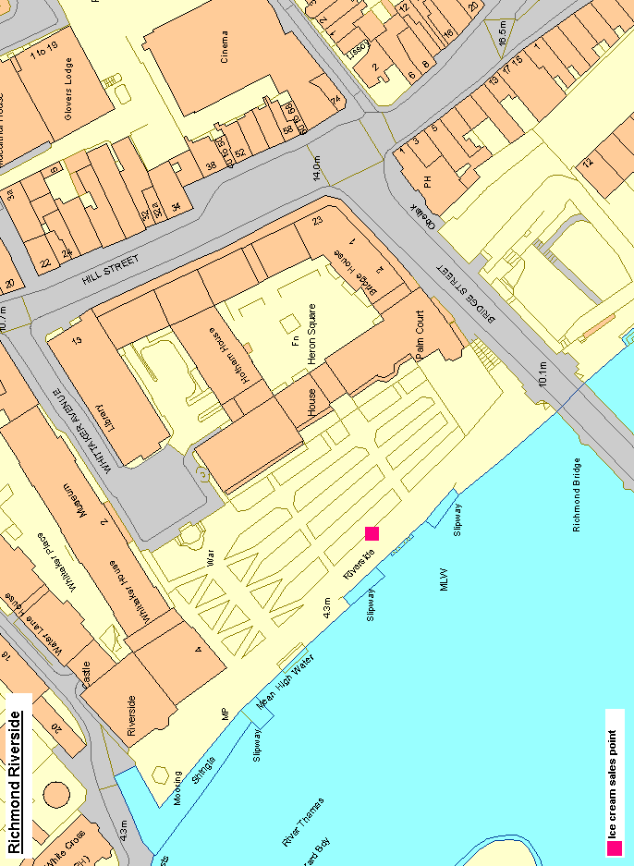
Lot 1 - Richmond Green

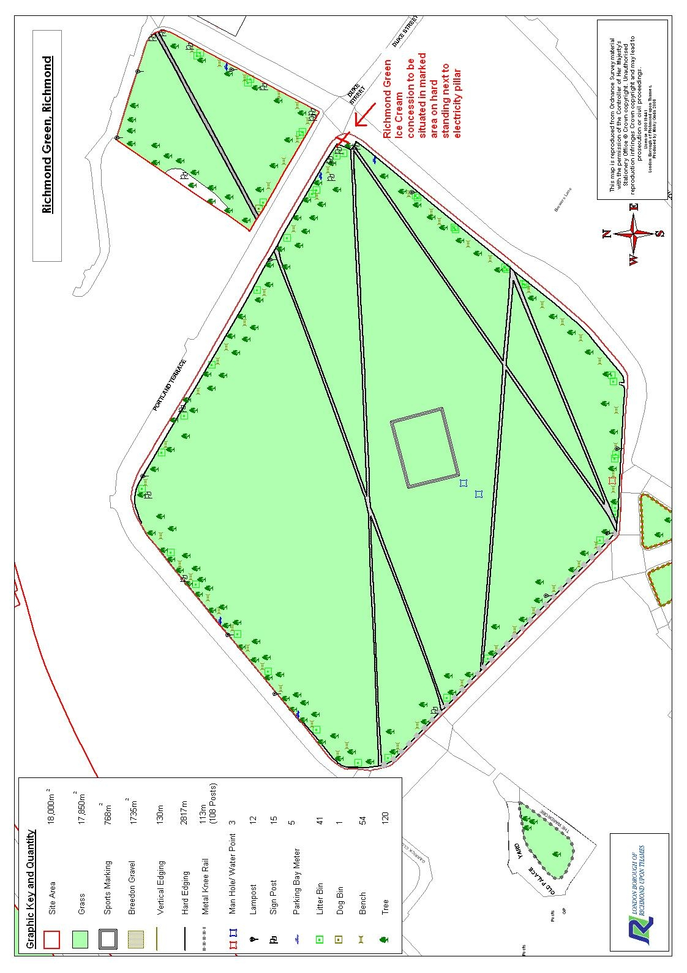
Lot 1 - Ham Street Car Park

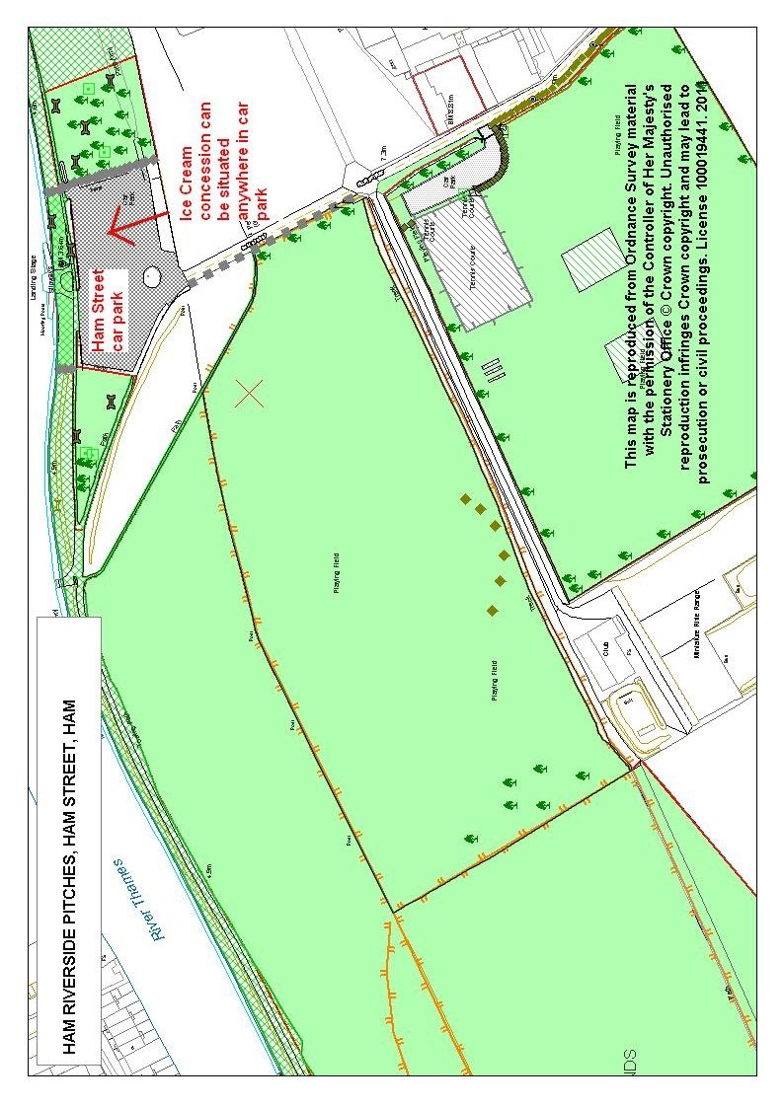
Lot 1 - Buccleuch Gardens
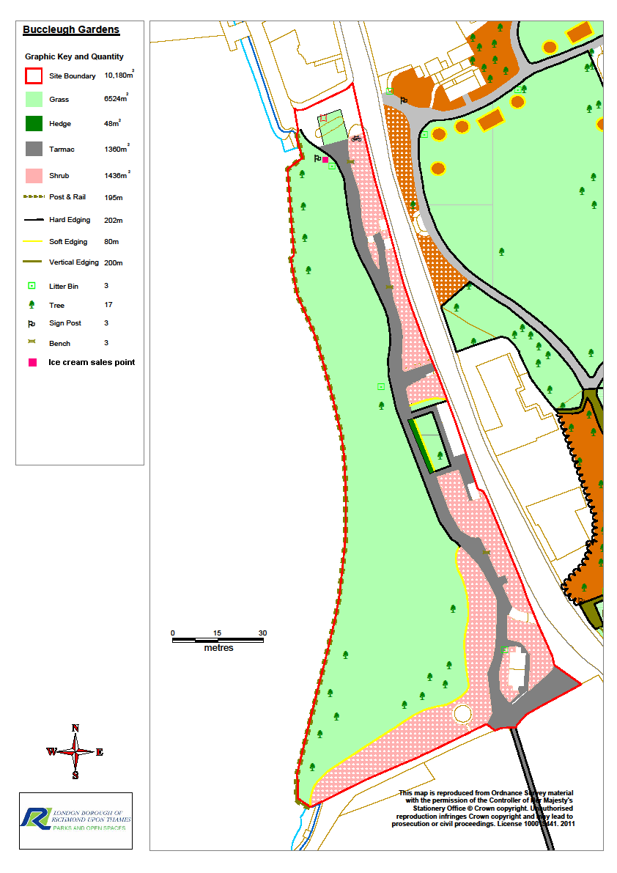

Lot 2 -Richmond Riverside

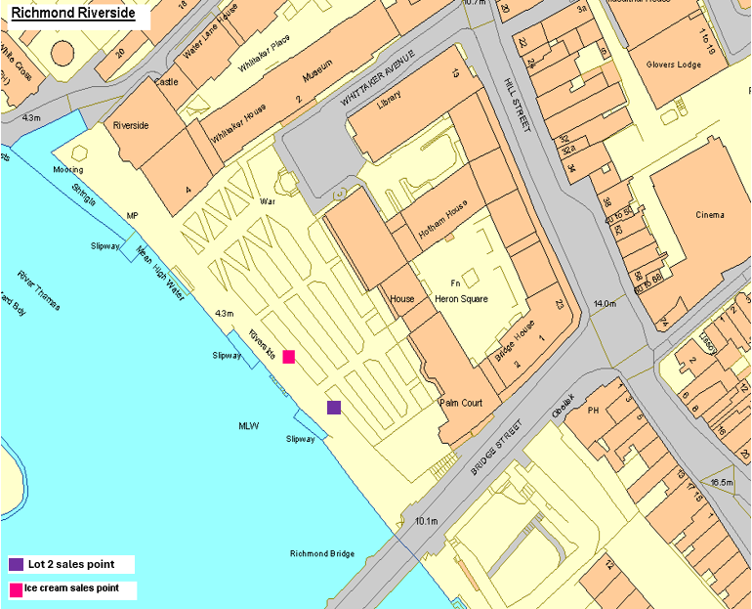

APPENDIX B – STREET TRADING LICENCE CONDITIONS

LONDON LOCAL AUTHORITIES ACT 1990 (AS AMENDED)

STREET TRADING

STANDARD CONDITIONS APPLIED TO LICENCE

Definitions: | 1. | In these Conditions unless the context otherwise requires, the expressions shown below will have the following meanings:
 |  | a) | “street trading" shall have the meaning ascribed in Section 21(1) of the London Local Authorities Act 1990(as amended).
 |  | b) | “The Council” means the London Borough of Richmond upon Thames.
 |  | c) | “Licensed Street Trader” means any person who is licensed for street trading under Part III of the London Local Authorities Act 1990(as amended
 |  | d) | “Advertisement” means any word, letter, model, sign, placard, board, notice, whether illuminated or not, used as an advertisement, announcement or direction, including any hoarding or similar structure or any balloon used or adapted for use for the display of advertisements.
 |  | e) | "Assistant" means a person employed by and acting under the directions of a trader to assist in the business of the stall and whose name and address has been notified to the Council.
 |  | f) | "Awning" means a sheet of canvas or other material, used as a protection against the weather, which projects as an extension of the roof beyond the structure of the receptacle.
 |  | g) | “Goods" means any goods, article, wares or merchandise exposed or offered for sale.
 |  | h) | “Licensed street trading pitch” means a pitch authorised for street trading and includes any temporary alternative place approved by the Council or a duly authorised officer of the Council.
 |  | i) | “Pitch Limits” means the authorised ground markings or the area stated on the licence defining the area within which street trading is to be contained.
 |  | j) | “Refuse” includes any waste material.
 |  | k) | “Receptacle” includes a vehicle or stall and any basket, bag, box, vessel, stand, easel, board, tray or thing which is used (whether or not constructed or adapted for such use) as a container for, or the display of any article or thing, or equipment used in the provision of any service.
 |  | l) | "Premises” means any shop, private forecourt, house, garden, open space or block of flatswithin 7 metres of the highway.
 |  | m) | "Trader” means a person in whose name a current licence is held.
 |  | n) | Authorised Officer” means an authorised officer of the Council or a police officer.

General: | 2. | a) | The grant of a street trading licence shall not be deemed to give any approval or consent which may be needed under any by-law, enactment or regulation other than Part III of the London Local Authorities Act 1990(as amended).
 |  | b) | The licence holder and any assistants shall comply with the Health & Safety at Work etc Act, food safety and food standards legislation where appropriate, trading standards legislation and any other applicable legislation.
 | 3. |  | The marginal notes inserted in these conditions are inserted for the purpose of convenience only and shall not in any way affect the meaning or construction thereof.
 | 4. | a) | These conditions may be dispensed with or modified by the Council in any individual case by means of a licence variation in accordance with the statutory requirements.
 |  | b) | Where in these conditions there is reference to the consent or agreement of the Council, such consent or agreement may be given on such terms and conditions and subject to such restrictions as may be specified.
 |  | c) | If a trader wishes any of the terms of a licence to be varied, application must be made in writing to the Council in accordance with the statutory requirements.
Position: | 5. | The trader shall trade only from the position as described on the licence or from any temporary alternative place approved by the Council or duly authorised officer of the Council.
Size: | 6. | During trading hours, the trading area shall not exceed the dimensions specified on the licence or pitch markings on the ground except during immediate re-stocking.
Boundary markings | 7. | No fixed boundary marking shall be allowed, e.g. planters/fence etc fixed to the highway (including pavement).
Conditions: | 8. | Only those goods or services specified on the licence may be sold or offered on the licensed street trading pitch.
Days and times: | 9. | Trading may only take place on the days and during the times specified on the licence.
Nature/type of receptacle: | 10. | The trader shall use only those receptacles that are approved by the Council.
Conduct: | 11. | a) | Traders and any assistants employed by them shall ensure the public are treated fairly and with courtesy.
 |  | b) | Traders shall ensure that no undue disturbance of the local area is caused by excessive shouting or calling of wares and items for sale. Any trader requested to refrain from such activities by an authorised officer or Police Officer must do so at once.
Display of licence: | 12. | A copy of the street trading licence must be prominently displayed on the receptacle at all times when trading.
Advertising: | 13. | No advertisement shall be displayed on the licensed pitch which relates to any goods, commodities or services other than that which is offered for sale or provided on that pitch.

Refuse: | 14. | Traders must provide suitable containers for refuse arising from their trading activity unless provided by the Council. Such refuse containers must be kept as clean as is reasonably possible. Traders are responsible for the removal of any refuse from their containers. The removal of such refuse must be completed within one and a half hours of the time prescribed on the street trading licence.
Heating  equipment: | 15. | The use and location of heat producing equipment within the designated trading area must be approved by an officer of the Council. Liquid petroleum gas (LPG) patio heaters are not approved.
Services and amenities: | 16. | Receptacles that are connected to services, e.g. electricity must have readily detachable connections and must have prior approval of an officer of the Council.
 | 17. | All electric power supplies shall have the written consent from the Council before seeking installation from the electricity provider.
 | 18. | Written permission shall be obtained from the Council before an electrical cable is hung across any part of the Public Highway. Cables shall be suspended to give a minimum clearance of 2.74m (9ft.) above footways and 5.3m (17ft 4ins) above carriageways.
 | 19. | Where mobile generators (diesel powered generators are encouraged) are used they shall be positioned so that:
 |  | a) | they do not present a danger to the passing public,
 |  | b) | they do not present a fire or similar risk/hazard to the receptacle or goods displayed thereon,
 |  | c) | they do not cause any noise or fume nuisance,
 |  | d) | any inflammable fuel is stored away from the receptacle in a London Fire & Emergency Planning Authority approved container.
 | 20. | a) | All electrical wiring and components shall comply with the Electricity at Work Regulations, the latest edition of IEE Regulations and British Standards Institution (BSI) BS 7671:2001. Electrical power shall only be used for the purposes of lighting, the operation of electrical scales and tills and the testing of electrical goods. A copy of the Portable Appliance Test (PAT) shall be submitted to the Council annually.
 |  | b) | If mains gas or LPG is used a safety certificate shall be submitted to the Council annually.
Headroom: | 21. | The distance above ground level of any part of any roof, awning, or supports of the receptacle or goods suspended from any of these, shall (unless a dispensation has been granted by the Council) be at least 2.74m (9ft). The roof awning or any other projection shall be contained within the pitch area unless agreed by the Council
Limits of display: | 22. | All goods, containers or other articles shall be contained within the limits of the licensed pitch including height. (Except for refuse containers used solely for that purpose).

Removal: | 23. | Receptacles shall be easily and immediately removable.
 | 24. | In the event of an emergency, or if required to do so by an authorised officer of the Council or by a police officer, traders or their assistant(s) must remove the stall/receptacle and goods for such time as required by the officials.
 | 25. | Receptacles and goods shall be removed from the public highway to the place of storage at the end of trading.
Trader’s vehicle: | 26. | A licensed trader shall not leave a vehicle in the street in which he/she trades, apart from in approved parking spaces such as meter bays and unrestricted areas or outside hours of restriction. Vehicles used for loading and unloading are not exempt from parking or highway restrictions.
Damage: | 27. | Traders must not allow receptacles or accessories to cause damage to the carriageway or footway.
Assistance to Council Officers: | 28. | Traders shall give every assistance to Council officers in carrying out their duties.
Change of Assistant: | 29. | Traders shall notify the Council in writing of the name of any assistant(s) employed on the receptacle, details of any change of assistant or any other relevant information regarding assistants.
Commencement times: | 30. | If the pitch is not utilised by the licensed trader by the time shown on the licence without the prior approval of the Council or its representative, the Council may at its discretion relet the pitch for that day.
Loudspeakers etc: | 31. | Loudspeakers shall not be used in the street for advertising any entertainment, trade or business. Vehicles which sell perishable foodstuffs (eg ice cream) are exempt but may only use loudspeakers between noon and 7.00pm. The loudspeaker must be used in such a way as not to give reasonable cause for annoyance to persons in the vicinity.
Insurance: | 32. | Traders shall take out third party insurance cover with a minimum liability of at least £5,000,000 and when trading shall display a valid certificate of cover.

Licensing
Civic Centre, 44 York Street
Twickenham TW1 3BZ
020 8831 6455
licensing@richmond.gov.uk

APPENDIX C – SAMPLE LICENCE APPLICATION FORM

APPLICATION FOR RENEWAL OF ITINERANT STREET TRADING LICENCE

1. | Full name of applicant ……………………………………………………………….……….…Mr/Mrs/Miss/Ms
2. | Home address ……………………………………………………………………………………………………….  …………………………………………………………………………………………………………………………  ……………………………………………………………………………..Postcode………………………………
3. | Daytime telephone no(s) ……………………………………………..…………………………………………...
4. | Location of pitch ………………………………………………………………….………………………….……….  …………………………………………………………………………………………………………..No …………
5. | Trading times  Day(s):……………………………………………..... Times: ……………………………..………………………..
6. | If private land, do you have written authority from the Landowner/ Tenant to trade there? Yes / No
7. | Please give the name and address of the relative you wish to “inherit” the pitch should you die or retire  ……………………………………………………………………………………………………… Mr/Mrs/Miss/Ms  ………………………………………………………………………………………………………………………….  Post code………………………………………………… Relationship ………………………………………….
The following must be submitted with your application

- Cheque payable to the London Borough of Richmond upon Thames for the appropriate fee
- Two full face passport photographs taken within the last 12 months
- full details, and photographs as b) above, of any employees and
- evidence of Public Liability Insurance cover to the value of £5,000,000 for the pitch
I wish to apply for renewal of street trading licence described above and confirm that the information given by me on this form is correct.
I realise that giving false information could lead to prosecution and the loss of any licence so granted.

Signed ………………………………………………………….. Dated ……………………………………………….
This application should be returned to: Licensing Team
2nd Floor, Civic Centre
44 York Street, Twickenham, TW1 3BZ
Tel: 020 8831 6455

